Asymmetric DCC correlation: AUDUSD and USDCAD
Method 10 / GARCH(1,1) + Cappiello-Engle-Sheppard ADCC / Alpari D1 full available history

Study setup
Logical pair: AUDUSD , USDCAD
Broker symbols: AUDUSD_i , USDCAD_i
Snapshot: 2026-11-03_majors_alpari_D1
Timeframe: D1
Matched return window: 1999-01-05 to 2026-11-02 (UTC bar dates)
Matched return count n: 7204
Dropped unfinished last bar dated 2026-11-03 UTC after a tick-volume check against the prior complete day.
AUDUSD GARCH(1,1): mu=0.000026, omega=0.005453, alpha=0.052367, beta=0.936935
USDCAD GARCH(1,1): mu=-0.000005, omega=0.001251, alpha=0.043587, beta=0.951301
ADCC: a=0.016345, b=0.981495, g=0.000000, a+b+g/2=0.997840
Nested DCC (g=0): a=0.016345, b=0.981495
Negative shock: n = min(z, 0) in broker quote direction (not inverted)
Burn-in ignored in path summaries and chart: first 60 updates
Complete matched rows (Excel): AUDUSD-USDCAD_ADCC_D1.xlsx
Complete matched rows (HTML table): AUDUSD-USDCAD_ADCC_D1_data.html

Method carried forward
Asymmetric DCC extends Engle DCC with an extra term on joint negative standardised shocks. Each matched daily log return of close, ln(close_t / close_t-1), is first filtered by a constant-mean GARCH(1,1). Then z = residual / sigma and n = min(z, 0). The Cappiello-Engle-Sheppard recursion uses A = (1-a-b) Q_bar - g N_bar with N_bar = mean(n n'). Quotes are not inverted, so a negative shock is a negative log return in the broker quote. Nested symmetric DCC (g = 0) is fit on the same z path for comparison. Constraints: a,b,g >= 0 and a + b + g/2 < 1. Path summaries ignore the first 60 updates. The headline is latest ADCC rho. Pearson r is a side check only. This is not a cause, lead, or trading signal.

Results
Latest ADCC rho: -0.512381
Latest nested DCC rho: -0.512381
Post-burn-in ADCC path (n=7144): mean=-0.602029, median=-0.616924, min=-0.853655, max=-0.030700, std=0.136283
Share of post-burn-in days with |rho| >= 0.4: 90.93%; |rho| >= 0.7: 27.76%
Same-sample Pearson r: -0.647362
ADCC minus r: 0.134980
ADCC minus nested DCC: -0.000000

Conclusion
Over 7204 matched daily log-return rows for AUDUSD and USDCAD (broker quote directions unchanged), latest ADCC rho is -0.5124 (negative, moderate conditional linear link in this sample) with fitted a=0.0163, b=0.9815, g=0.0000. Nested symmetric DCC latest rho is -0.5124 (ADCC minus DCC = -0.0000). After a 60-day burn-in, path mean is -0.6020 and std is 0.1363. Same-sample Pearson r is -0.6474 (ADCC minus r = 0.1350). This does not establish cause, lead-lag, or a lasting trading rule.

Charts
Daily closes

Daily log returns
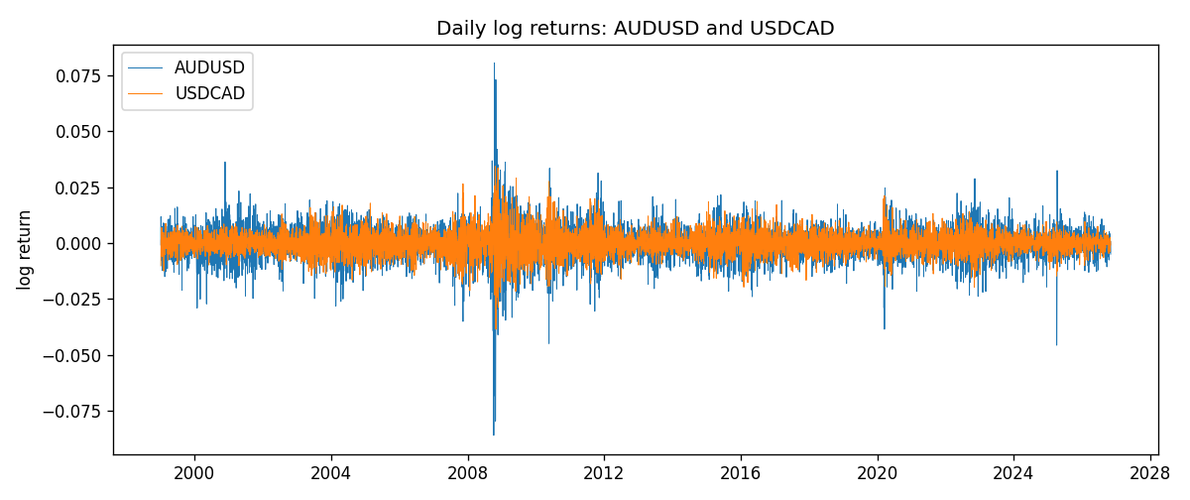
ADCC rho path with nested DCC and Pearson r
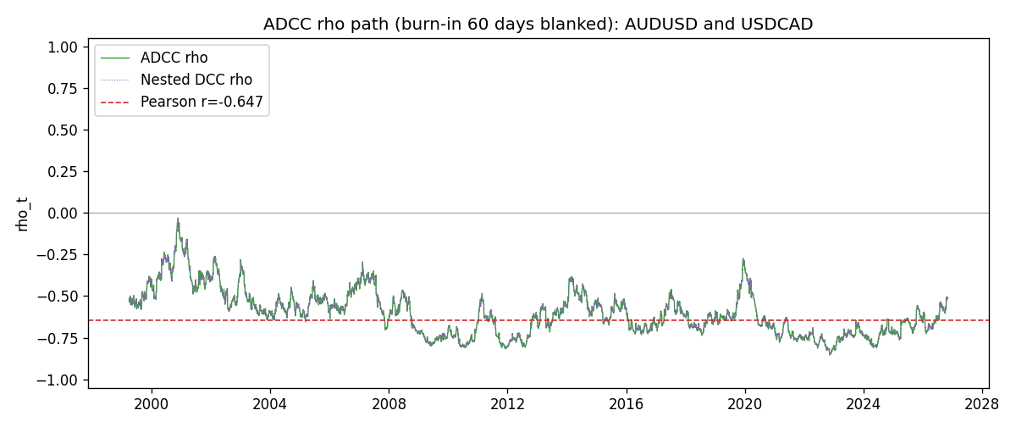

Data report
Every matched row that entered the ADCC recursion is stored in the sibling Excel workbook named AUDUSD-USDCAD_ADCC_D1.xlsx. Embedding all rows as a Word table is impractical at this length; the Word file holds the column list, column summaries, and the first and last 15 matched rows.
Columns: time, AUDUSD_open, USDCAD_open, AUDUSD_high, USDCAD_high, AUDUSD_low, USDCAD_low, AUDUSD_close, USDCAD_close, AUDUSD_tick_volume, USDCAD_tick_volume, AUDUSD_spread, USDCAD_spread, AUDUSD_real_volume, USDCAD_real_volume, AUDUSD_log_return, USDCAD_log_return, AUDUSD_sigma, USDCAD_sigma, AUDUSD_z, USDCAD_z, AUDUSD_n, USDCAD_n, q11, q22, q12, rho_adcc, rho_dcc
Column summaries (matched calculation rows)
column | count | mean | std | min | 25% | 50% | 75% | max
AUDUSD_open | 7204 | 0.75193151 | 0.13526075 | 0.4785 | 0.6610425 | 0.731405 | 0.8086175 | 1.10284
USDCAD_open | 7204 | 1.2670146 | 0.16899756 | 0.9168 | 1.118975 | 1.298545 | 1.372225 | 1.6183
AUDUSD_high | 7204 | 0.7559812 | 0.13582551 | 0.4878 | 0.6647 | 0.734785 | 0.81467 | 1.10795
USDCAD_high | 7204 | 1.2719163 | 0.16895637 | 0.9336 | 1.123375 | 1.30394 | 1.3767575 | 1.619
AUDUSD_low | 7204 | 0.74787477 | 0.13457623 | 0.4775 | 0.6577 | 0.727495 | 0.8042 | 1.0975
USDCAD_low | 7204 | 1.2624553 | 0.16903522 | 0.9056 | 1.11435 | 1.293585 | 1.3678925 | 1.6102
AUDUSD_close | 7204 | 0.75197934 | 0.13524694 | 0.4786 | 0.6611975 | 0.731695 | 0.808875 | 1.10169
USDCAD_close | 7204 | 1.2670334 | 0.16897258 | 0.916 | 1.11848 | 1.298615 | 1.372515 | 1.6137
AUDUSD_tick_volume | 7204 | 77316.143 | 138115.43 | 109 | 5421.75 | 43310.5 | 71296.75 | 1234623
USDCAD_tick_volume | 7204 | 80846.476 | 147183.52 | 56 | 5511.25 | 40857 | 71531.75 | 1410818
AUDUSD_spread | 7204 | 30.823709 | 16.885829 | 0 | 13 | 30 | 50 | 50
USDCAD_spread | 7204 | 23.505275 | 18.28107 | 0 | 9 | 17 | 40 | 60
AUDUSD_real_volume | 7204 | 5.2399076e+09 | 1.2535442e+11 | 0 | 0 | 0 | 0 | 3.811512e+12
USDCAD_real_volume | 7204 | 1.8332738e+10 | 9.6584767e+10 | 0 | 0 | 0 | 0 | 2.5751613e+12
AUDUSD_log_return | 7204 | 2.007e-05 | 0.0075444 | -0.08602525 | -0.00386183 | 0.00027895 | 0.00414528 | 0.0806166
USDCAD_log_return | 7204 | -1.21e-05 | 0.00514438 | -0.03859748 | -0.00283637 | 4.97e-05 | 0.00272781 | 0.03436319
AUDUSD_sigma | 7204 | 0.00694014 | 0.00278932 | 0.00391317 | 0.00551021 | 0.00627169 | 0.00757697 | 0.0385231
USDCAD_sigma | 7204 | 0.00479616 | 0.00181265 | 0.00250953 | 0.00365782 | 0.00435957 | 0.00535498 | 0.01852324
AUDUSD_z | 7204 | -0.00443752 | 1.0001161 | -8.4717557 | -0.60511812 | 0.04108321 | 0.63808234 | 5.0034557
USDCAD_z | 7204 | 0.00155192 | 1.0000853 | -4.0699542 | -0.62904867 | 0.01125213 | 0.61272602 | 6.4180013
AUDUSD_n | 7204 | -0.38797207 | 0.62451982 | -8.4717557 | -0.60511812 | 0 | 0 | 0
USDCAD_n | 7204 | -0.38705432 | 0.588337 | -4.0699542 | -0.62904867 | 0 | 0 | 0
q11 | 7204 | 1.0019173 | 0.16369329 | 0.66219472 | 0.90092512 | 0.97888512 | 1.0737318 | 2.1867695
q22 | 7204 | 1.0015374 | 0.14442232 | 0.68163889 | 0.90803165 | 0.98381065 | 1.0702877 | 1.8427364
q12 | 7204 | -0.60493415 | 0.17564441 | -1.3086015 | -0.70698453 | -0.61348187 | -0.49264112 | -0.03102365
rho_adcc | 7204 | -0.60149584 | 0.13585266 | -0.85365471 | -0.70989179 | -0.61557121 | -0.52395152 | -0.03070044
rho_dcc | 7204 | -0.60149584 | 0.13585264 | -0.85365475 | -0.70989176 | -0.61557119 | -0.52395153 | -0.03070052
First 15 matched rows (selected columns)
time | AUDUSD_log_return | USDCAD_log_return | AUDUSD_z | USDCAD_z | AUDUSD_n | USDCAD_n | q11 | q22 | q12 | rho_adcc | rho_dcc
1999-01-05 | -0.00080418179 | -0.010131666 | -0.13249177 | -2.2378484 | -0.13249177 | -2.2378484 | 1 | 1 | -0.60334858 | -0.60334858 | -0.60334858
1999-01-06 | 0.011836351 | -0.0003306769 | 1.9328823 | -0.066301932 | 0 | -0.066301932 | 0.98394171 | 1.0655111 | -0.58864042 | -0.57489219 | -0.57489219
1999-01-07 | 0.0088650256 | 0.0015202092 | 1.3506244 | 0.31789357 | 0 | 0 | 1.0289599 | 1.0480254 | -0.58114544 | -0.55962834 | -0.55962833
1999-01-08 | 0.00031515916 | -0.0020495197 | 0.043267314 | -0.434477 | 0 | -0.434477 | 1.0418955 | 1.0324433 | -0.56467656 | -0.54444571 | -0.5444457
1999-01-11 | 0.0072213815 | -0.0035137769 | 1.1038438 | -0.75903106 | 0 | -0.75903106 | 1.0248056 | 1.0185832 | -0.55583761 | -0.54403763 | -0.54403761
1999-01-12 | -0.0048608485 | 0.0066194721 | -0.74456791 | 1.4461382 | -0.74456791 | 0 | 1.0279175 | 1.011311 | -0.56054982 | -0.54978479 | -0.54978478
1999-01-13 | -0.0078902098 | 0.0045420214 | -1.2192583 | 0.96945892 | -1.2192583 | 0 | 1.0201172 | 1.0289395 | -0.56907965 | -0.55546042 | -0.5554604
1999-01-14 | -0.002696916 | 0.0069376546 | -0.41365654 | 1.4817014 | -0.41365654 | 0 | 1.0276983 | 1.0274208 | -0.57917233 | -0.56363871 | -0.5636387
1999-01-15 | 0.007123101 | -0.0056905671 | 1.1014605 | -1.1825152 | 0 | -1.1825152 | 1.0136374 | 1.046453 | -0.57977609 | -0.56293613 | -0.56293611
1999-01-18 | 0.00094592471 | 0.00098344542 | 0.14185536 | 0.20387977 | 0 | 0 | 1.0168701 | 1.0521044 | -0.59163999 | -0.57199913 | -0.57199912
1999-01-19 | 0.0072225153 | 0.002748513 | 1.1376237 | 0.57999438 | 0 | 0 | 1.0005416 | 1.0354744 | -0.58152207 | -0.57131937 | -0.57131936
1999-01-20 | 0.0012507819 | -0.0059646885 | 0.19190652 | -1.2733581 | 0 | -1.2733581 | 1.0053401 | 1.0239711 | -0.5612793 | -0.55319553 | -0.55319551
1999-01-21 | 0.00078094498 | -0.0042823796 | 0.12124025 | -0.90149554 | 0 | -0.90149554 | 0.98949804 | 1.0336851 | -0.55619016 | -0.54994809 | -0.54994807
1999-01-22 | -0.012252745 | 0.0025057712 | -2.0203019 | 0.53134512 | -2.0203019 | 0 | 0.97358743 | 1.0300002 | -0.54898748 | -0.5482218 | -0.54822177
1999-01-25 | -0.0039591468 | 0.00085579808 | -0.60734682 | 0.18509076 | -0.60734682 | 0 | 1.024446 | 1.0177145 | -0.55767781 | -0.54616749 | -0.54616747
Last 15 matched rows (selected columns)
time | AUDUSD_log_return | USDCAD_log_return | AUDUSD_z | USDCAD_z | AUDUSD_n | USDCAD_n | q11 | q22 | q12 | rho_adcc | rho_dcc
2026-10-13 | 0.0035007712 | -0.0046395653 | 0.76897087 | -1.6058533 | 0 | -1.6058533 | 0.77008003 | 0.81870432 | -0.44847643 | -0.56481751 | -0.56481744
2026-10-14 | -0.0015193215 | 0.0015184751 | -0.34279992 | 0.50841275 | -0.34279992 | 0 | 0.76765476 | 0.84786453 | -0.4616645 | -0.57224271 | -0.57224265
2026-10-15 | -0.0075447063 | -0.0036101503 | -1.7055432 | -1.2170804 | -1.7055432 | -1.2170804 | 0.75752994 | 0.83855961 | -0.45727327 | -0.57373182 | -0.57373176
2026-10-16 | 0.0033906408 | -0.0034322068 | 0.7173198 | -1.1399554 | 0 | -1.1399554 | 0.79321797 | 0.84941384 | -0.41618545 | -0.50702685 | -0.50702681
2026-10-19 | 0.0050859986 | -0.0018835331 | 1.0848916 | -0.6180835 | 0 | -0.6180835 | 0.78910973 | 0.85709586 | -0.42315281 | -0.5145337 | -0.51453366
2026-10-20 | 0.0034620426 | -0.0037066008 | 0.72817495 | -1.2294589 | 0 | -1.2294589 | 0.79590527 | 0.84963946 | -0.42758588 | -0.51996646 | -0.51996642
2026-10-21 | 0.0036066384 | -0.00084691787 | 0.76295095 | -0.27530806 | 0 | -0.27530806 | 0.79200377 | 0.86078366 | -0.43560981 | -0.52757842 | -0.52757838
2026-10-22 | -0.0012672558 | -0.0026307268 | -0.27654946 | -0.87295436 | -0.27654946 | -0.87295436 | 0.78902205 | 0.84825357 | -0.43228528 | -0.52840026 | -0.52840022
2026-10-23 | 0.0023765656 | 2.85545e-05 | 0.51165037 | 0.01128945 | 0 | 0 | 0.77783114 | 0.84717235 | -0.42164303 | -0.51941725 | -0.51941722
2026-10-26 | -0.0032032829 | 5.7106554e-05 | -0.71116242 | 0.021162985 | -0.71116242 | 0 | 0.7698762 | 0.83365735 | -0.41504928 | -0.51807834 | -0.51807829
2026-10-27 | 0.0016669876 | 0.0025379458 | 0.36334028 | 0.87668822 | 0 | 0 | 0.76605614 | 0.82039769 | -0.40891798 | -0.51581467 | -0.51581463
2026-10-28 | 0.0040915541 | -0.0038379274 | 0.91361028 | -1.3213123 | 0 | -1.3213123 | 0.75619798 | 0.81993872 | -0.39744759 | -0.50474429 | -0.50474424
2026-10-29 | -0.0040915541 | -0.00011436495 | -0.92138304 | -0.036807262 | -0.92138304 | -0.036807262 | 0.75800749 | 0.83546218 | -0.41112737 | -0.51662598 | -0.51662594
2026-10-30 | 0.0010102376 | -0.0010298736 | 0.21938375 | -0.35207464 | 0 | -0.35207464 | 0.76001666 | 0.82218395 | -0.40426831 | -0.51141522 | -0.51141518
2026-11-02 | -0.0049184984 | 0.00061519094 | -1.1205734 | 0.21636565 | -1.1205734 | 0 | 0.74889911 | 0.81115538 | -0.399353 | -0.5123813 | -0.51238125

